CHAPLAIN: Rev'd Nathanial N
Pat’anka 2614/11A, 160 00, Praha 6 – Dejvice.
Telephone: 233 310 266. Mobile: 737 039 082
Email: chaplain@anglican.cz Website: http://www.anglican.cz

CHURCH COUNCIL:
Adenubi Babatunde, Alexander Rupert Felsing, Andrew Kasembe, Anna Hayden, Bethany Danel Brooks, Caleb Harris, Peter Broster, Polina Lynch, Robert Anderson, Ted Hollis
Reader: John Noonan

Churchwardens:
Stephen Weeks- 606 400 800 & Paul Evans- 602 769 582
Safeguarding: Alexander Rupert Felsing safeguarding@anglican.cz
Rota: Ted Hollis- tedhollisnh@gmail.com
Environment – Peter Broster peter@broster.cz
Usher– Paul Portway

St Clement’s Anglican Episcopal Church is part of the Church of England’s Diocese in Europe and is the English-speaking Parish of the Old Catholic Church in the Czech Republic. It is prayerfully supported by the Intercontinental Church Society (ICS).
Please be aware that this Church is self-supporting and costs around 25,000 Kč (that is approximately £900, €1000 or $1200) per week to run. Please give generously & help us to sustain our ministry to visitors and residents in Prague and the Czech Republic. If you are a UK taxpayer, please complete a Gift Aid envelope available from a Welcomer at the back of the Church or transfer directly to our UK Bank account number 40317039 IBAN: GB16 BUKB 2006 1340317039 Swiftbic BUKBGB22. When sending donation please put note/message: for St. Clement's, Prague or Czech bank account at Česká Spořitelna, number/bankcode 6146762339/0800. IBAN: CZ13 0800 0000 0061 4676 2339 You can also make donations using Paypal through: donations@anglican.cz. For any query contact the treasurer- kasembeandrew@gmail.com.
READINGS FOR NEXT SUNDAY –Sixth Sunday after Trinity
Gen 25.19-34, Rom 8.1-11 and Matt 13:1-9,18-23

Please take this Bulletin home with you but return the Order of Service & Hymnbook to the back of the Church.
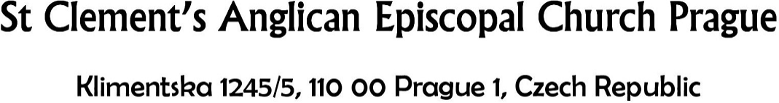

5th July 2026 | Fifth Sunday after Trinity
Morning Prayer

Preacher: John Noonan
Organist: Professor Michal Novenko

Hymns:
616 Stand up and bless the Lord.........Carlisle
613 Spirit of Mercy, Truth and Love...Warrington
463 My song is love unknown ............Love Unknown
A Debtor to Mercy alone ..................Trewen

COLLECT
Almighty God, send down upon your Church the riches of your Spirit,
and kindle in all who minister the gospel your countless gifts of grace;
through Jesus Christ our Lord.. Amen
 Old Testament Reading: Genesis 24. 34-38, 42-49, 58-67
So he said, ‘I am Abraham’s servant. The Lord has greatly blessed my master, and he has become wealthy; he has given him flocks and herds, silver and gold, male and female slaves, camels and donkeys. And Sarah my master’s wife bore a son to my master when she was old; and he has given him all that he has. My master made me swear, saying, “You shall not take a wife for my son from the daughters of the Canaanites, in whose land I live; but you shall go to my father’s house, to my kindred, and get a wife for my son.”
I came today to the spring, and said, “O Lord, the God of my master Abraham, if now you will only make successful the way I am going! I am standing here by the spring of water; let the young woman who comes out to draw, to whom I shall say, ‘Please give me a little water from your jar to drink,’ and who will say to me, ‘Drink, and I will draw for your camels also’—let her be the woman whom the Lord has appointed for my master’s son.” ‘Before I had finished speaking in my heart, there was Rebekah coming out with her water-jar on her shoulder; and she went down to the spring, and drew. I said to her, “Please let me drink.” She quickly let down her jar from her shoulder, and said, “Drink, and I will also water your camels.” So I drank, and she also watered the camels. Then I asked her, “Whose daughter are you?” She said, “The daughter of Bethuel, Nahor’s son, whom Milcah bore to him.” So I put the ring on her nose, and the bracelets on her arms. Then I bowed my head and worshipped the Lord, and blessed the Lord, the God of my master Abraham, who had led me by the right way to obtain the daughter of my master’s kinsman for his son. Now then, if you will deal loyally and truly with my master, tell me; and if not, tell me, so that I may turn either to the right hand or to the left.’
And they called Rebekah, and said to her, ‘Will you go with this man?’ She said, ‘I will.’ So they sent away their sister Rebekah and her nurse along with Abraham’s servant and his men. And they blessed Rebekah and said to her, ‘May you, our sister, become thousands of myriads; may your offspring gain possession of the gates of their foes.’ Then Rebekah and her maids rose up, mounted the camels, and followed the man; thus the servant took Rebekah, and went his way. Now Isaac had come from Beer-lahai-roi, and was settled in the Negeb. Isaac went out in the evening to walk in the field; and looking up, he saw camels coming. And Rebekah looked up, and when she saw Isaac, she slipped quickly from the camel, and said to the servant, ‘Who is the man over there, walking in the field to meet us?’ The servant said, ‘It is my master.’ So she took her veil and covered herself. And the servant told Isaac all the things that he had done. Then Isaac brought her into his mother Sarah’s tent. He took Rebekah, and she became his wife; and he loved her. So Isaac was comforted after his mother’s death.

 New Testament Reading: Matthew 11. 16-19, 25-30
'But to what will I compare this generation? It is like children sitting in the market-places and calling to one another, “We played the flute for you, and you did not dance; we wailed, and you did not mourn.” For John came neither eating nor drinking, and they say, “He has a demon”; the Son of Man came eating and drinking, and they say, “Look, a glutton and a drunkard, a friend of tax-collectors and sinners!” Yet wisdom is vindicated by her deeds.’
At that time Jesus said, ‘I thank you, Father, Lord of heaven and earth, because you have hidden these things from the wise and the intelligent and have revealed them to infants; yes, Father, for such was your gracious will. All things have been handed over to me by my Father; and no one knows the Son except the Father, and no one knows the Father except the Son and anyone to whom the Son chooses to reveal him.‘Come to me, all you that are weary and are carrying heavy burdens, and I will give you rest. Take my yoke upon you, and learn from me; for I am gentle and humble in heart, and you will find rest for your souls. For my yoke is easy, and my burden is light.’

Notices & Forthcoming Events

Following Prayer, there will be Coffee Hour in the hall on the third floor of Klimentská 18.

Sunday 12th July at 13.00 – Sung Eucharist for the Sixth Sunday after Trinity will be held in the Church of St. Joseph (Kostel Sv. Josefa) Náměstí Republiky 110 00 Praha 1 (near Palladium).

Wednesday 15th July at 17:00, Evensong from the Book of Common Prayer will be held in the Rotunda of the finding of the Holy Cross Karoliny Světlé 1013 110 00 Praha.
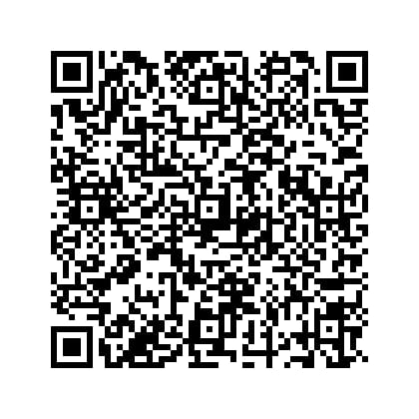
If you wish to donate to St. Clement's, Here is the QR CODE:

