CHAPLAIN: Rev'd Nathanial N
Pat’anka 2614/11A, 160 00, Praha 6 – Dejvice.
Telephone: 233 310 266. Mobile: 737 039 082
Email: chaplain@anglican.cz Website: http://www.anglican.cz

CHURCH COUNCIL:
Andrew Kasembe, Bethany Danel Brooks, Caleb Harris, James Mansfield, Phillip Harriot, Ted Hollis
Reader: John Noonan

Churchwardens:
Stephen Weeks- 606 400 800 & Paul Evans- 602 769 582
Safeguarding: Alexander Rupert Felsing safeguarding@anglican.cz
Rota: Ted Hollis- tedhollisnh@gmail.com
Environment – James Mansfield jamesrmansfield@gmail.com
Usher– Paul Portway

St Clement’s Anglican Episcopal Church is part of the Church of England’s Diocese in Europe and is the English-speaking Parish of the Old Catholic Church in the Czech Republic. It is prayerfully supported by the Intercontinental Church Society (ICS).
Please be aware that this Church is self-supporting and costs around 25,000 Kč (that is approximately £900, €1000 or $1200) per week to run. Please give generously & help us to sustain our ministry to visitors and residents in Prague and the Czech Republic. If you are a UK taxpayer, please complete a Gift Aid envelope available from a Welcomer at the back of the Church or transfer directly to our UK Bank account number 40317039 IBAN: GB16 BUKB 2006 1340317039 Swiftbic BUKBGB22. When sending donation please put note/message: for St. Clement's, Prague or Czech bank account at Česká Spořitelna, number/bankcode 6146762339/0800. IBAN: CZ13 0800 0000 0061 4676 2339 You can also make donations using Paypal through: donations@anglican.cz. For any query contact the treasurer- kasembeandrew@gmail.com.
READINGS FOR NEXT SUNDAY – Trinity Sunday
Psalm 8 ; Isaiah 40. 12-17 & 27-31 ; Matthew 28. 16-20

Please take this Bulletin home with you but return the Order of Service & Hymnbook to the back of the Church.

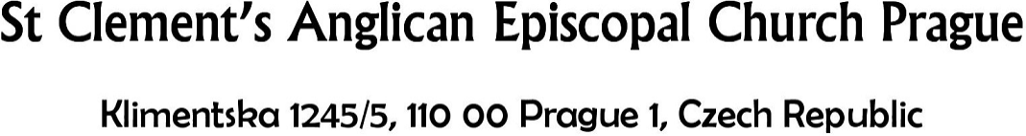
24th May 2026 | Feast of Pentecost
Sung Eucharist

Celebrant: Rev'd Nathanial N
Preacher: John Noonan
Choir Coordinator: Adenubi Babatunde
Organist: Professor Michal Novenko

Hymns:
672 Thine be the Glory Judas Maccabaeus
118 Come Holy Ghost Veni Creator
408 Lord Enthroned in Heavenly Splendour St. Helen
428 Love Divine all Love Excelling Blaenwern

 FIRST READING Acts 2. 1-21
See pages 4 & 5 of the Order of Service

 SECOND READING 1 Corinthians 12. 3b-13
No one can say ‘Jesus is Lord’ except by the Holy Spirit. Now there are varieties of gifts, but the same Spirit; and there are varieties of services, but the same Lord; and there are varieties of activities, but it is the same God who activates all of them in everyone. To each is given the manifestation of the Spirit for the common good. To one is given through the Spirit the utterance of wisdom, and to another the utterance of knowledge according to the same Spirit, to another faith by the same Spirit, to another gifts of healing by the one Spirit, to another the working of miracles, to another prophecy, to another the discernment of spirits, to another various kinds of tongues, to another the interpretation of tongues. All these are activated by one and the same Spirit, who allots to each one individually just as the Spirit chooses. For just as the body is one and has many members, and all the members of the body, though many, are one body, so it is with Christ. For in the one Spirit we were all baptized into one body – Jews or Greeks, slaves or free – and we were all made to drink of one Spirit.

 HOLY GOSPEL John 7. 37-39
On the last day of the festival, the great day, while Jesus was standing in the temple, he cried out, ‘Let anyone who is thirsty come to me, and let the one who believes in me drink. As the scripture has said, “Out of the believer’s heart shall flow rivers of living water.” Now he said this about the Spirit, which believers in him were to receive; for as yet there was no Spirit, because Jesus was not yet glorified.

Notices & Forthcoming Events

